2020-05-18

Homework 5

CESG506

Kristinn Hlíðar Grétarsson

All code used for solving the homework can be found under course github.

# Problem 1

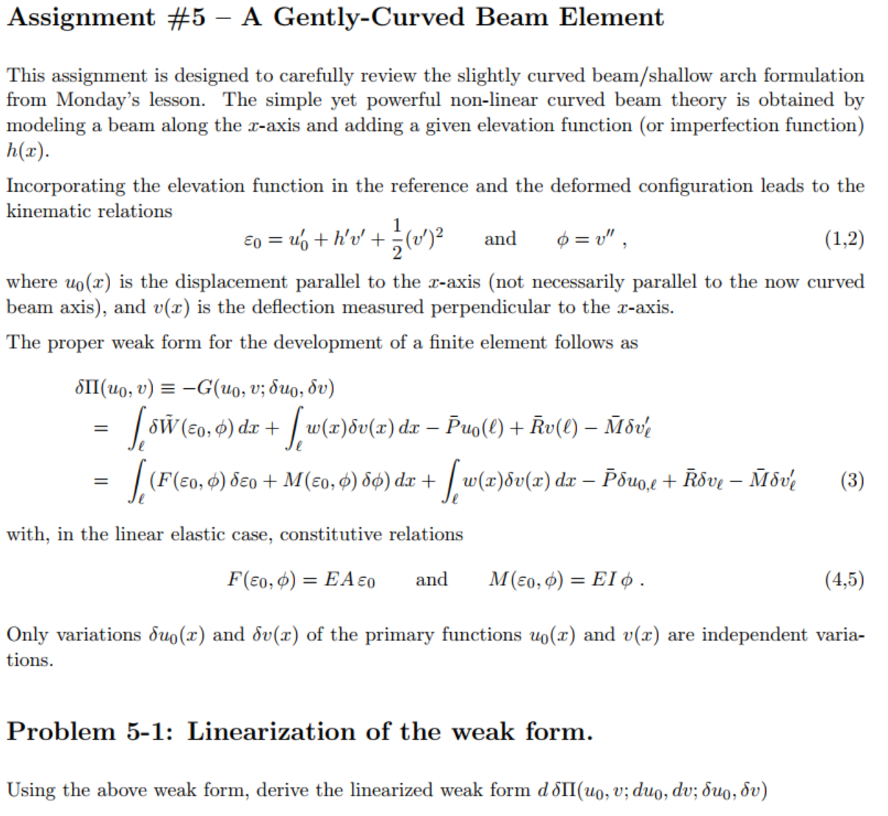

# Problem 2

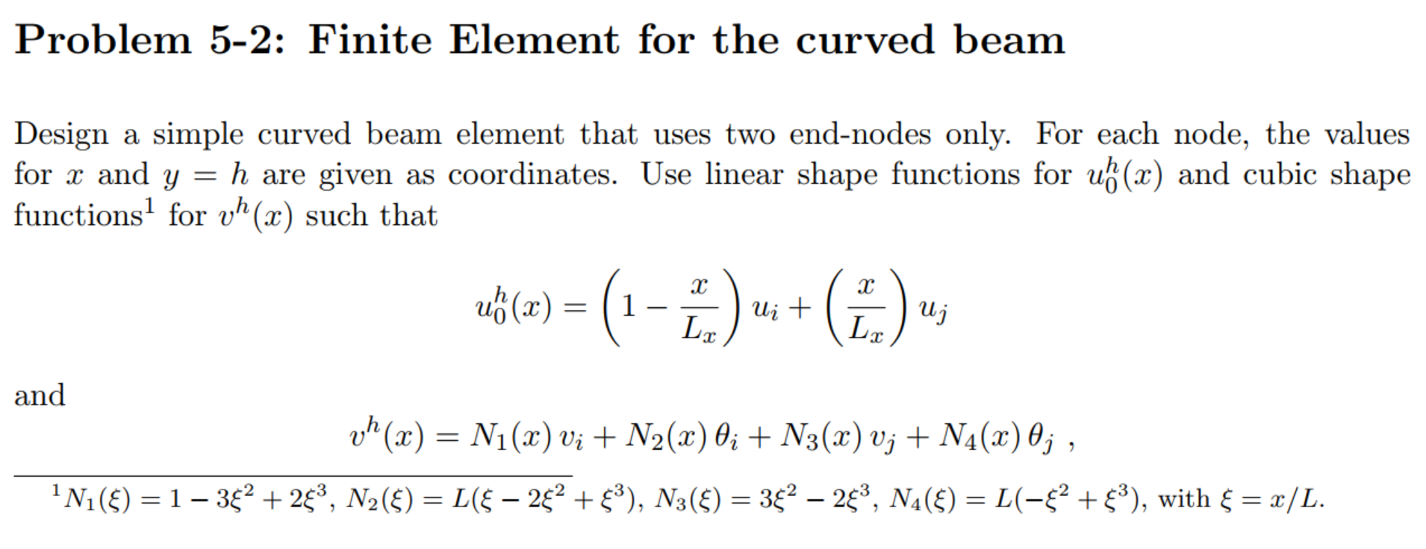

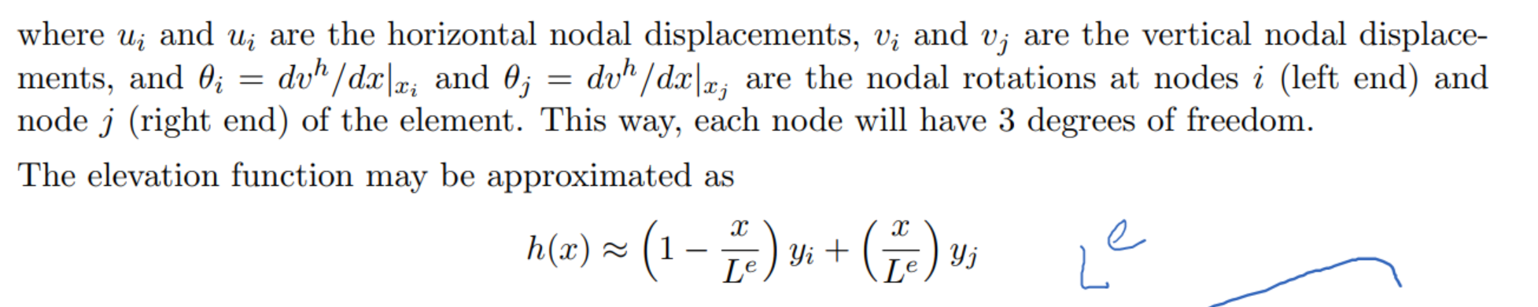

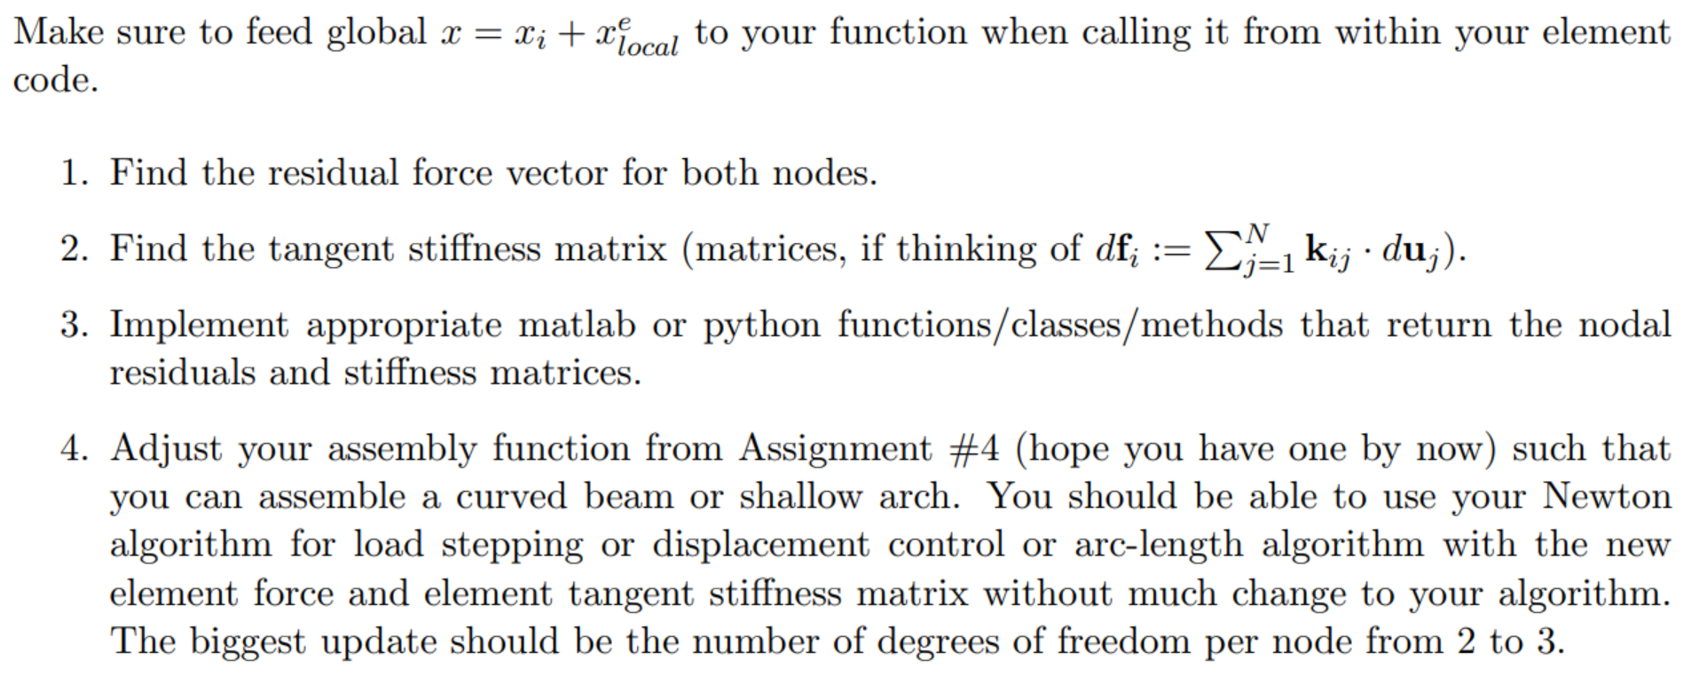

# Problem 3

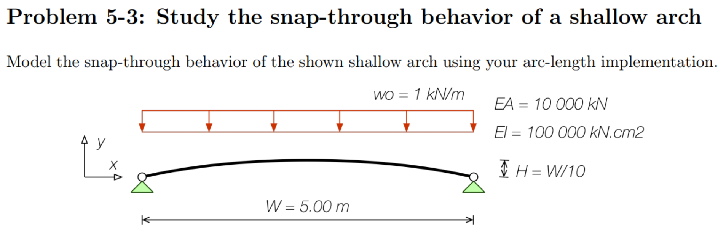

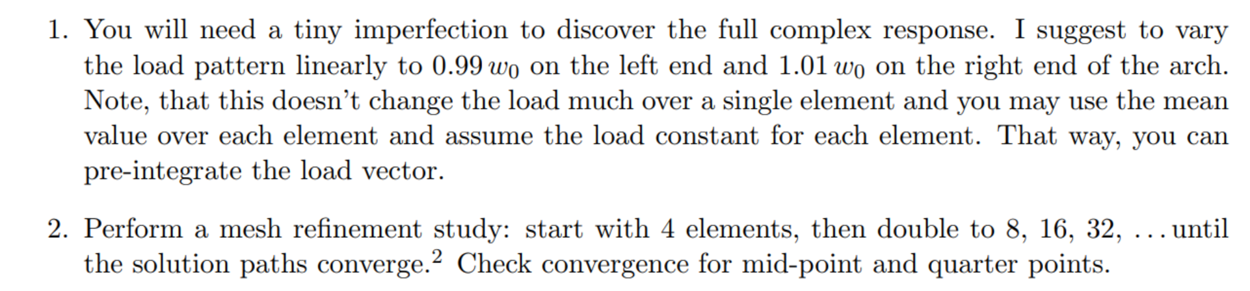

## Solution

Code was run with increasingly finer mesh and vertical displacement of ¼ point, ½ point and ¾ point were plotted. The results can be seen in the images below.

For meshes with 4 and 8 elements the beam behaves in a wildly different manner. Once the mesh refinement hits 16 elements or higher, the solution paths start to converge to a set path.

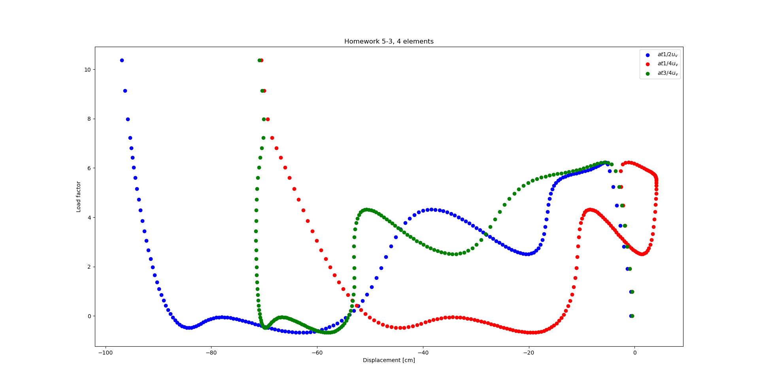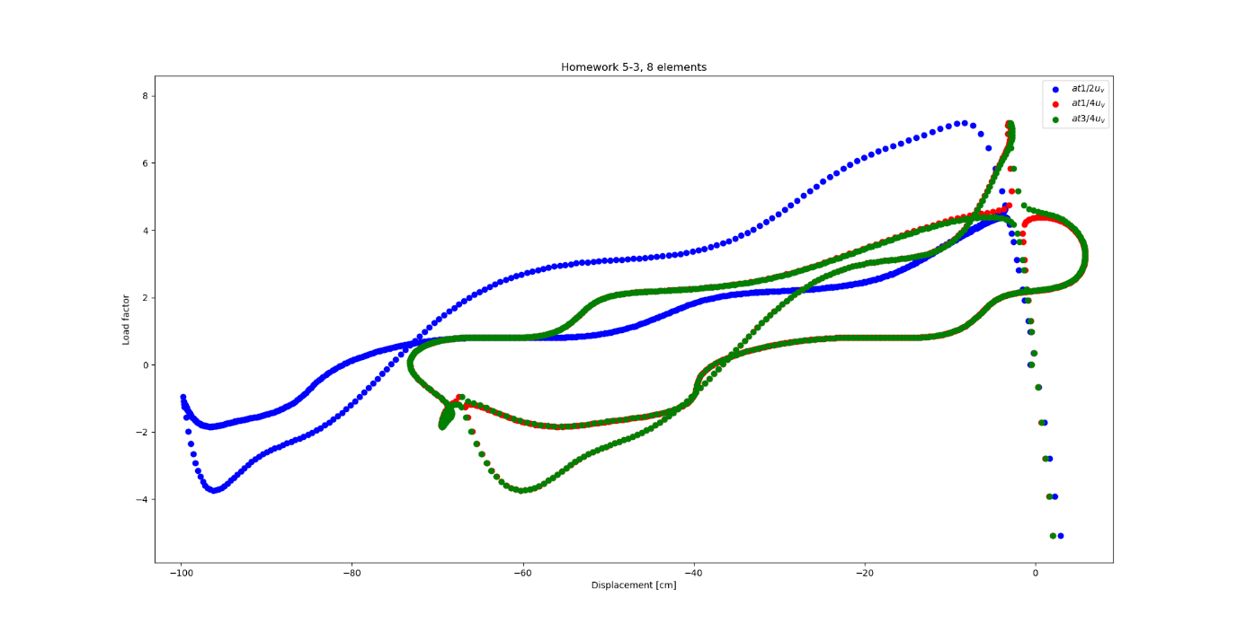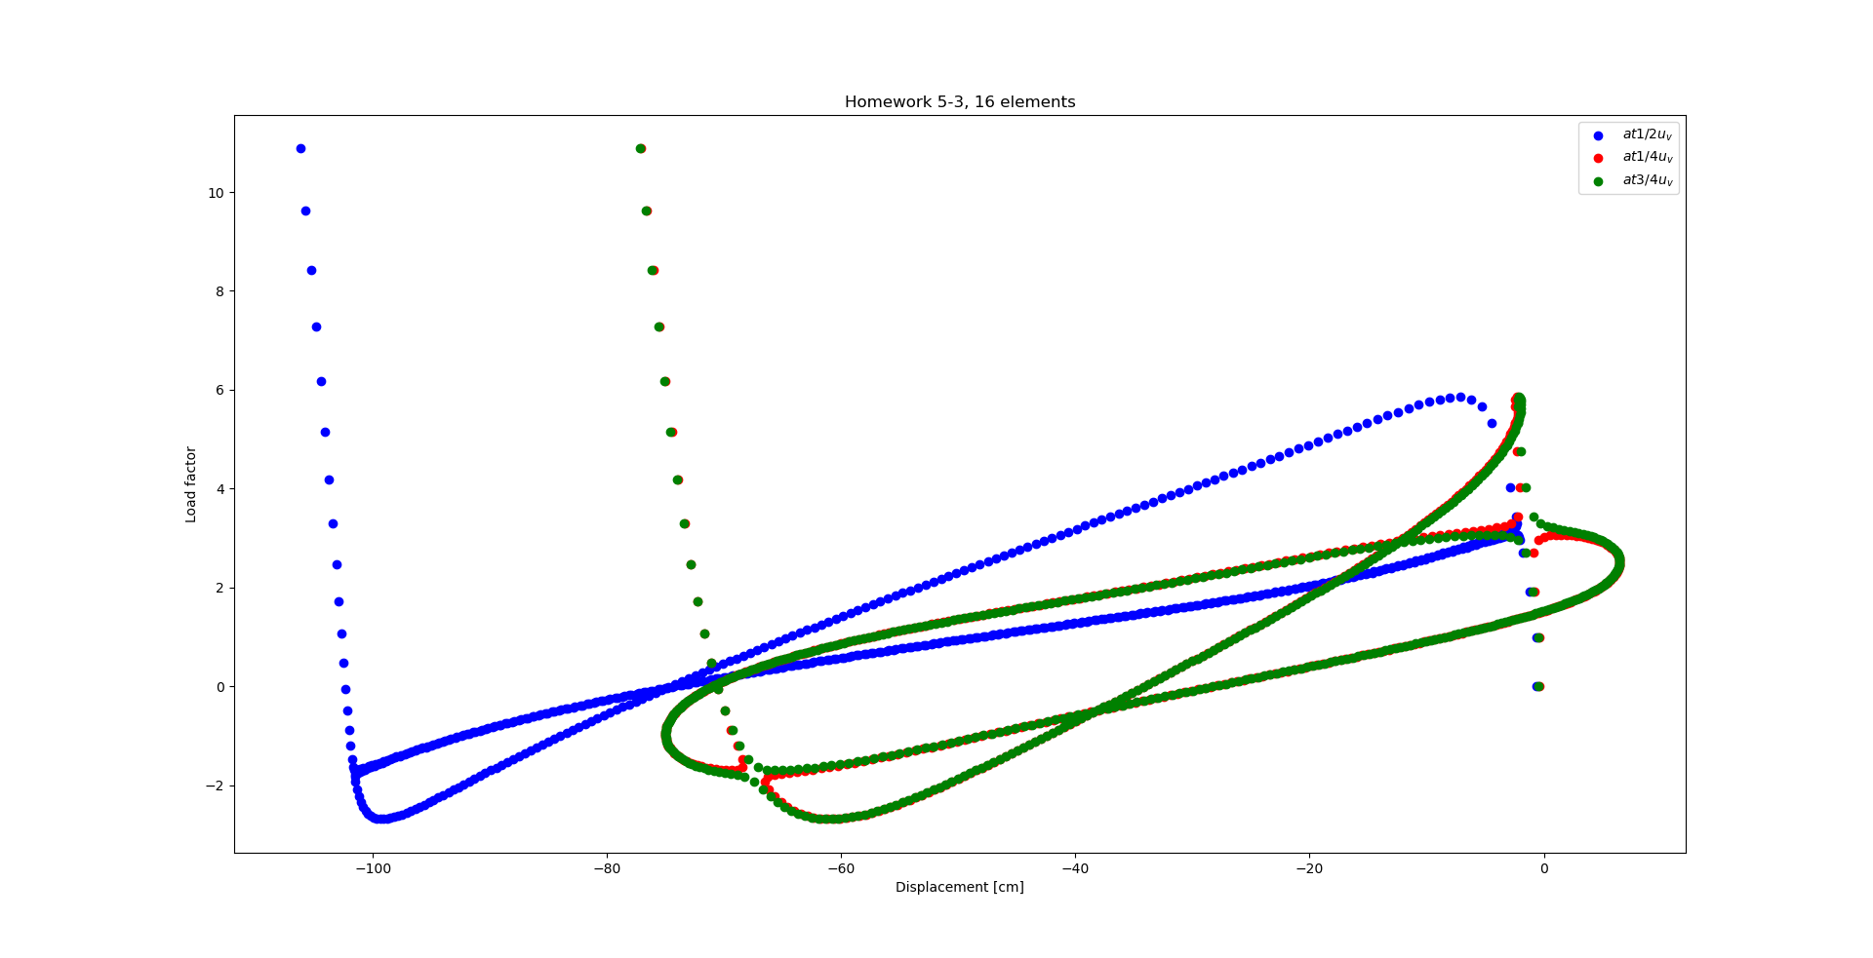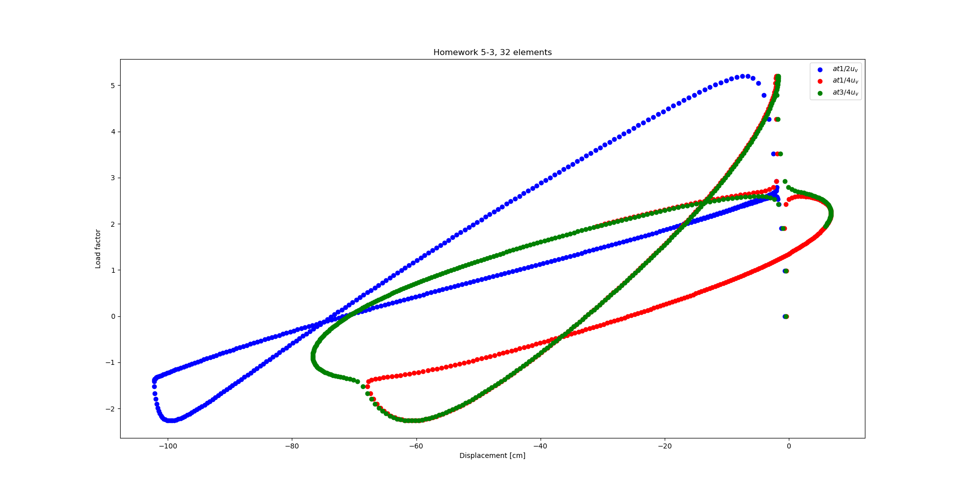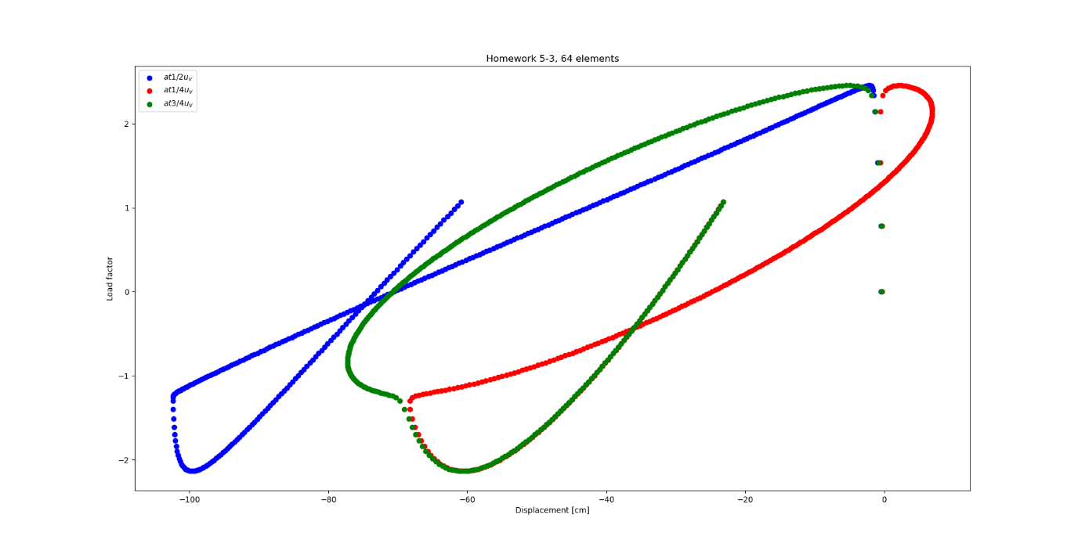

# Problem 4

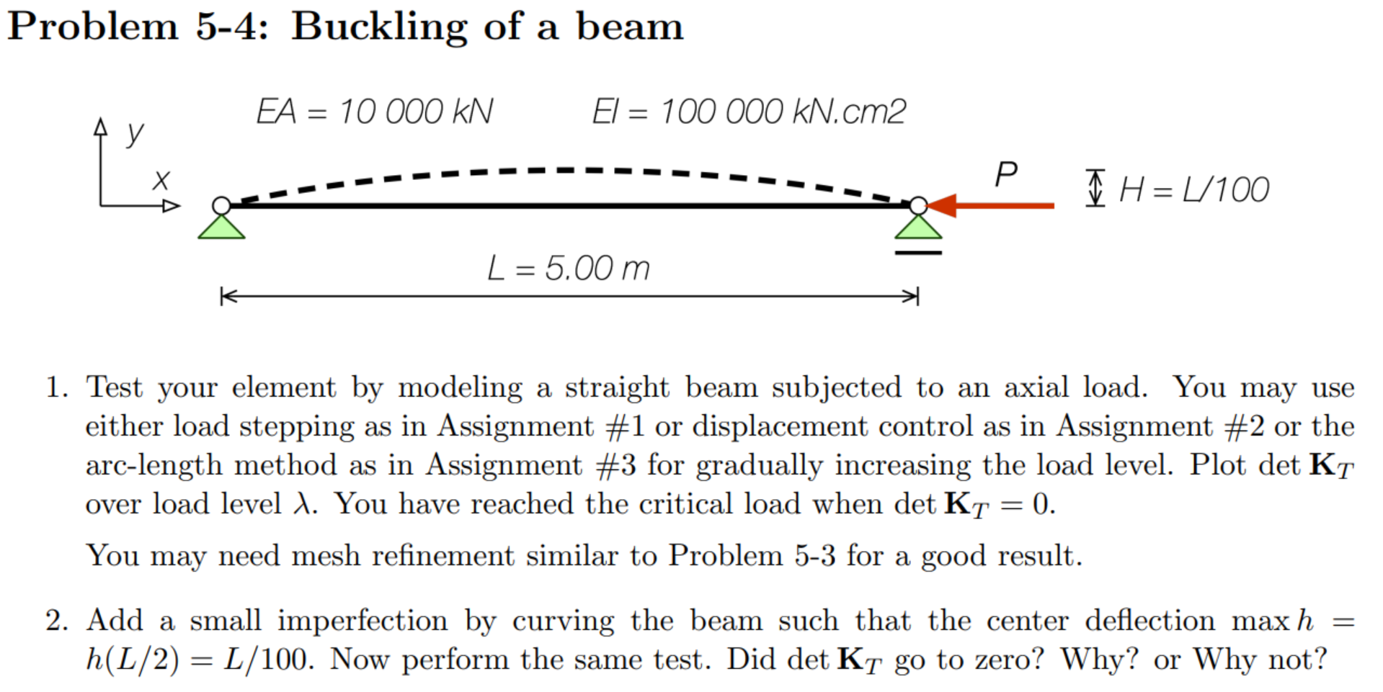

## Solution – Straight beam

Plotting determinant of the stiffness matrix over load factor shows that the stiffness matrix becomes singular at the theoretical buckling capacity.

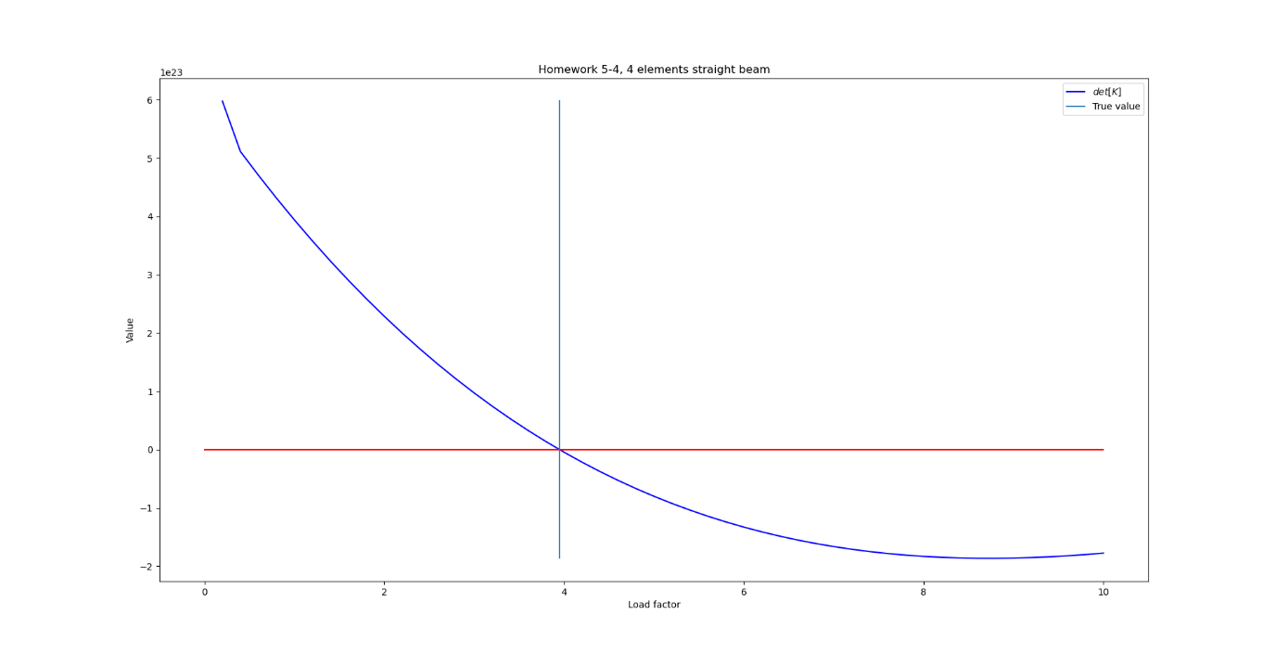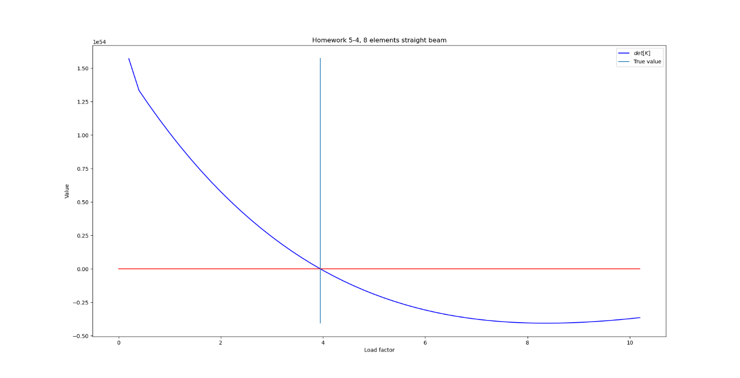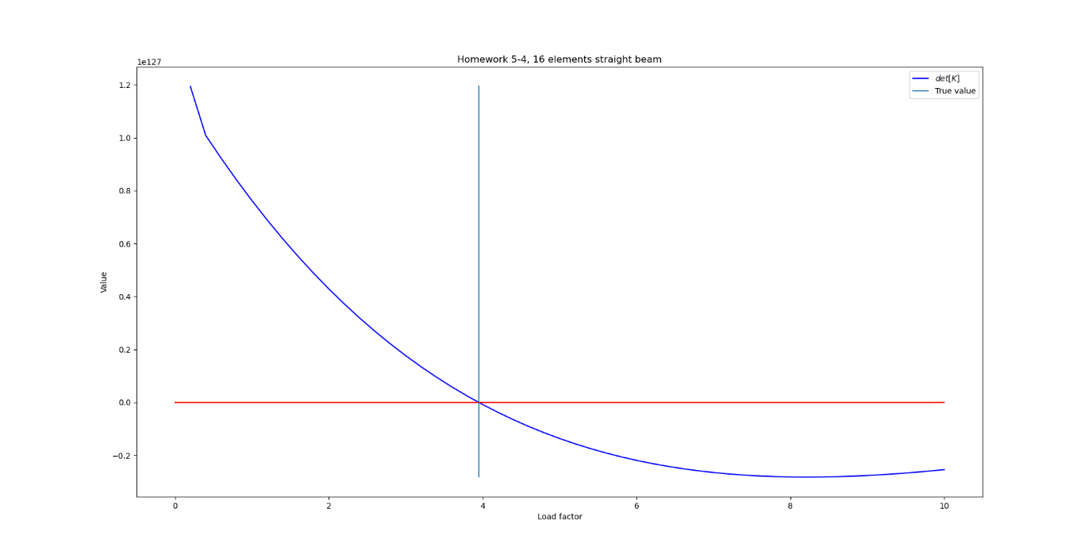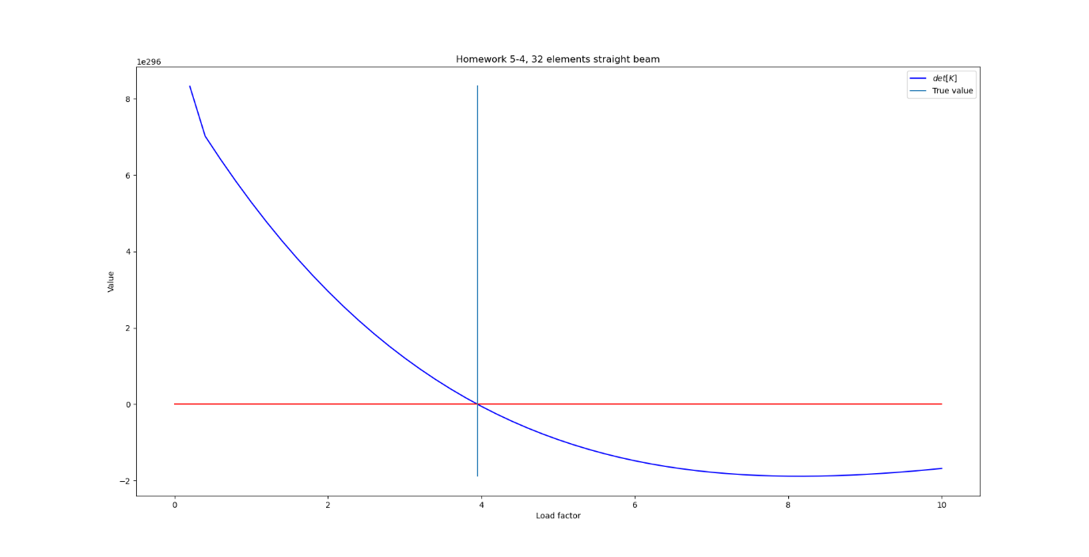

## Solution – Curved beam

Adding a small curve to the beam changed the behaviour. The matrix no longer turned singular at any point. Furthermore, when the minimum eigenvalue of the stiffness matrix was plotted, it showed it also never became zero.

